Significant Events/ Incidents/Trends

Friendly Reminders

Is your home fire safe? Contact Puslinch Fire & Rescue Services for a free home inspection.

Smoke Alarms
If anyone in the household sleeps with the bedroom door closed, install an alarm inside their bedroom. Never remove batteries from a smoke alarms. If nuisance alarms are a problem, try moving the alarm to another location or purchase an alarm with a "hush feature" that temporarily silences the alarm. Smoke alarms should be replaced every 10 years.
Please test your smoke alarms once a month and the batteries be replaced every year.
Make sure that everyone in the household knows what to do if the smoke alarm sounds.

Carbon monoxide
Learn more about Ontario's new CO Alarm Law. Many lives could be saved and suffering could be prevented if citizens were fully informed and capable of recognizing and preventing the dangers of carbon monoxide

poisoning. Preventive efforts such as checking furnace flues, chimneys, and vents could help to alleviate the hazard. The use of good common sense in not using open flames, ovens, and other appliances not intended for heating could reduce the number of carbon monoxide-related incidents. It's also recommended that homeowners have their complete heating systems inspected before every heating season.
Fire Escape Planning
Know 2 ways out, Practice your fire escape plan today!
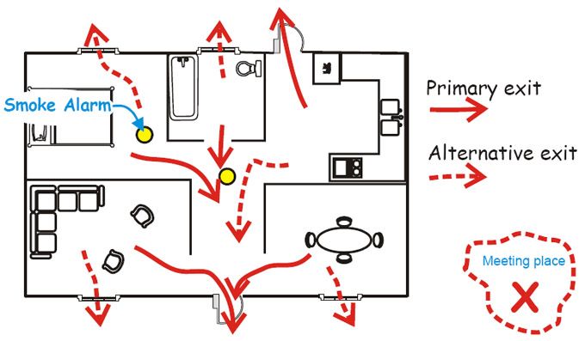
REPORT MONTH: | 2015 June
 |  | June Monthly Total | June 2015  YTD | June 2014 YTD | June 2013 YTD | June  $ Loss Monthly | June 2015 $ Loss YTD
FIRE: | Structure | 0 | 6 | 7 | 7 | $0 | $0
 | Vehicular | 2 | 10 | 9 | 14 | $0 | $0
 | Grass and Bush | 0 | 6 | 2 | 3 | $0 | $0
 | Other | 2 | 2 | 3 | 8 | 0
 |  | Monthly | 2015 YTD | 2014 YTD | 2013 YTD
Motor Vehicle Collisions |  | 12 | 76 | 96 | 48
Medical Assist |  | 2 | 34 | 28 | 26
Mutual Aid |  | 0 | 7 | 4 | 1
Carbon Monoxide |  | 2 | 9 | 6 | 4
Automatic Alarm |  | 2 | 15 | 20 | 13
Burning Complaints |  | 2 | 7 | 10 | 6
Incorrect Page |  | 0 | 0 | 4 | 1
Other |  | 2 | 5 | 9 | 10
TOTALS: |  | Monthly | 2015 YTD | 2014 YTD | 2013 YTD
 |  | 26 | 177 | 198 | 141
Estimated Total Dollar Loss Due to Fire |  | $0 | $123,000 | $505,000 | $620,000

.

Grass Fire 3%
Prevention & Public Education | 2015 June
Activity: | Monthly Total | 2015 YTD
Inspections | 3 | 19
Water Tank Inspection | 2 | 33
Investigations | 0 | 7
Emergency Planning | 1 | 11
Public Education Volunteer | 1 | 6
Public Education Paid | 2 | 4
Meeting | 2 | 17
Home Safe Home Campaign | 0 | 0

Professional Development
Activity Month Day
Home Safe Home Campaign Training June 2 & 3
Fire Master Plan Preliminary Findings June 11
Medical June 16 & 17
Live Fire Training Cambridge June/July 23/24 & 7/8
Water Rescue Training July 14,15,21,22

MVC – Large Fuel Leak Nicholas Beaver Road
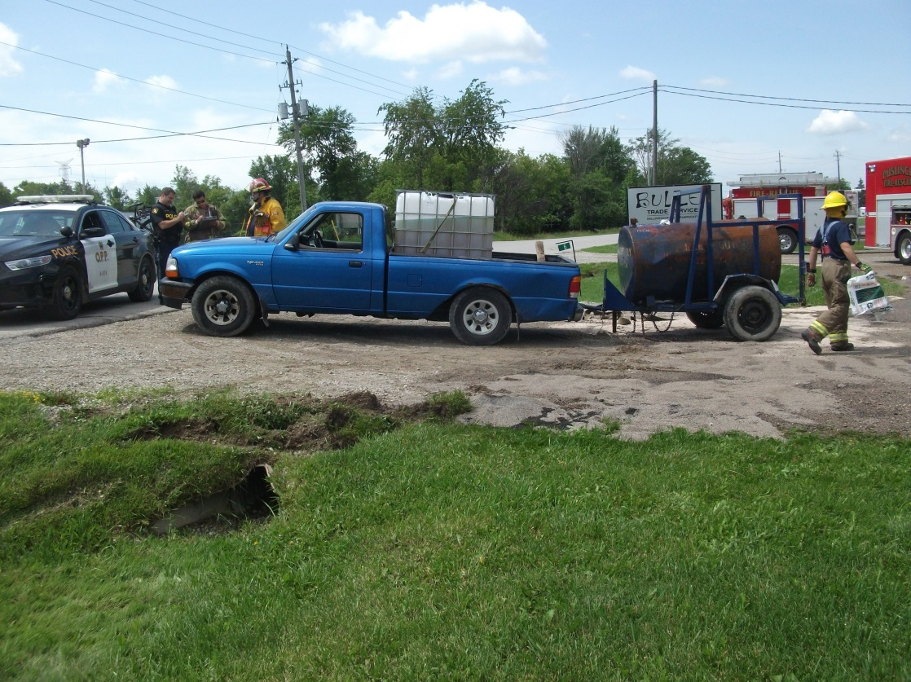
MVC – Large Fuel Leak Highway 401 Service Centre
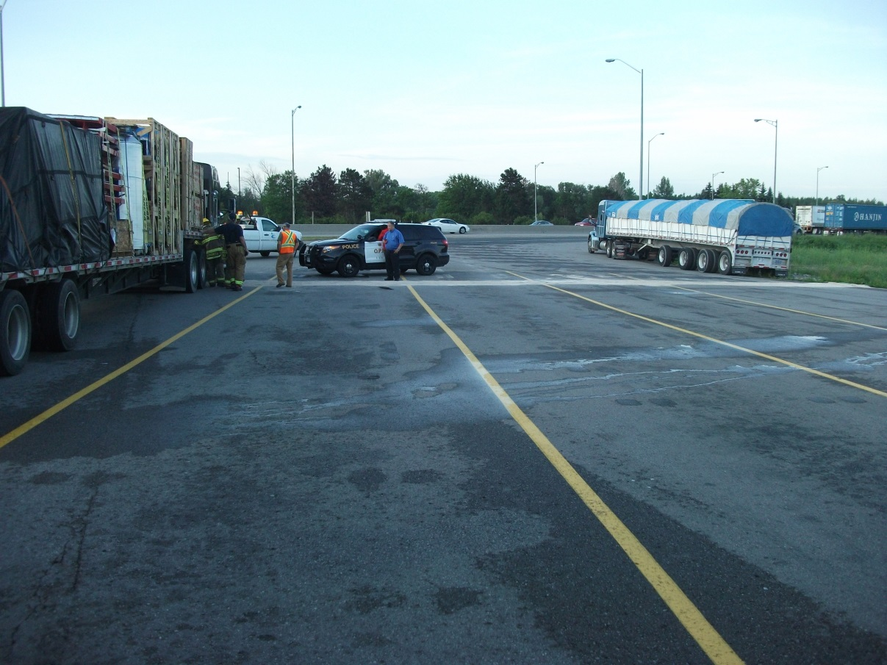

Fire Department Open House
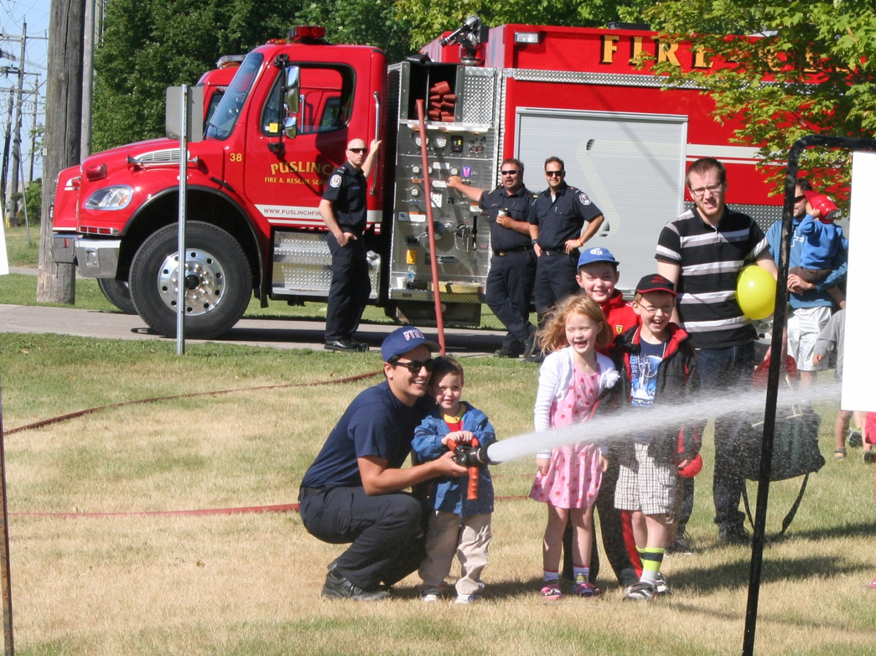
FIRE DEATHS

Total fatal fires for the period from January 1 to July 8 for the years 2014 and 2015
 | 2014 |  | 2015
 | Fatal fires | Fatalities | Fatal fires | Fatalities
Ontario fatal fires (except federal and First Nations properties) from January 1 to July 8 | 34 | 44 | 54 | 60
Fatal fires on federal or First Nations properties from January 1 to July 8 | 2 | 5 | 2 | 2
Total | 36 | 49 | 56 | 62

